SHIVGADHI ENGLISH SCHOOL
Shivraj-1, Kapilvastu
1st Terminal Examination 2081
Class: Nursery F.M.
Subject: Math
Name: ________________________________________________ Roll.No. _______________
Writing
Write 1 to 4
_________ _________ ___________ ___________
Reading
1 2 3 4
Speaking
How many fingers are there?
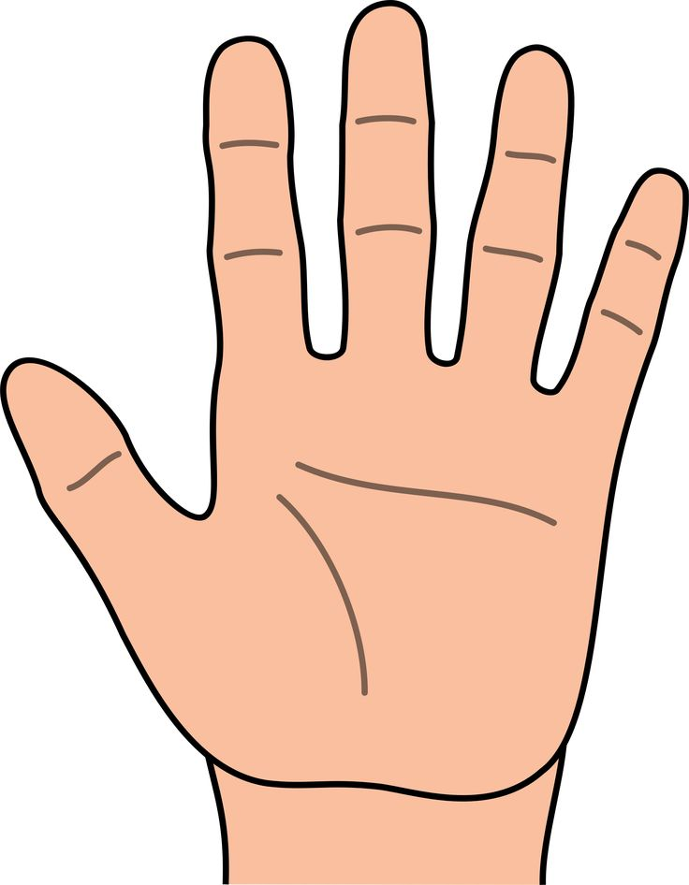

How many apples are there?


How many balls are there?


THE END

